Commtheroy project

Team members:
Ziad Ahmed Fergany 55-10227
Nayera Khalil Yasso 55-11834
Abdelrahman Eltonie 46-10502

Agenda:
1-code
2- comments on the code
3-output graphs of the code

1-The code:
clc
clear all
close all
% Sampling
figure(1);
subplot(3, 1, 1)
t = 0:0.1:30;
x = sin(4*pi.*t);
plot(t, x)
subplot(3, 1, 2)
ts = t(1:2:end);
xs = x(1:2:end);
stem(ts, xs)
subplot(3, 1, 3)
plot(t, x)
hold on
stem(ts, xs)
% Quantization
xsample = [0.733, 0.733, 0.2, 0.7];
levels = [2,4,8,16,32];
QuantizedValues = zeros(1, length(xs));
mean_qunatized_error = zeros(1, length(levels));
VarPractical = zeros(1, length(levels));
VarTheoretical = zeros(1, length(levels));
SQNR_theoretical = zeros(1, length(levels));
SQNR_practical = zeros(1, length(levels));
CR= zeros(1,length(levels));
eita= zeros(1, length(levels));
for k = 1:length(levels)
L = levels(k)
delta = (max(x) - min(x)) / L ;
xq = ((L-1)/2) * delta * -1: delta: ((L-1)/2) * delta;
disp(['Quantized Values for L=' num2str(L) ':']);
for i = 1:length(xs)
[~, index] = min(abs(xs(i) - xq));
QuantizedValues(i) = xq(index);
pos(i) = index-1;
end
mean_qunatized_error(k) = mean(abs(xs - QuantizedValues));
VarPractical(k) = var(abs(xs - QuantizedValues));
VarTheoretical(k) = ((delta).^2)/12;
%SQNR_practical(k) = max(xs)^2 / VarPractical(k);
SQNR_practical(k) = max(x).^2 / VarPractical(k);
SQNR_theoretical(k) = 3 .* ((L).^2);
u=[0:1:levels(k)-1];
frequency=histc(pos,[0:1:levels(k)-1]);
prob=frequency/length(pos);
dict=huffmandict(u,prob);
enc=huffmanenco(pos,dict);
dec=huffmandeco(enc,dict);
rec_data=enc;
check= dec-pos;
dec= delta*dec + (-1*(L-1)* delta/2);
figure(k+1);
plot(t,x);
hold on;
title('L=',L);
plot(ts,dec);
xlabel('Input');
ylabel('Output');
logp=log2(prob);
logp(find(logp==-inf))= 0; %to solve the problem of log(0)*0
H_array=(prob.*logp)*-1;
H=sum(H_array); %entropy
Isk=-1*logp; %self info, represnts no. of bits used for each symbol (decimal)
v= ceil(Isk); %ength of the code word assigned to each level of the source enc
Length_array= prob.*v; %gives an array of the probability of each level occurence *its code length
avLength = sum(Length_array);% L av
NumberOffSymbolsUsed= length(prob)-length(find(prob==0));
CR(k)=ceil(log2(NumberOffSymbolsUsed))/avLength; % (Lfixed= no. of used quantization levels) / Laverage
eita(k)= H/avLength;
end
figure(length(levels)+1 + 1);
subplot(3, 1, 1);
title('Mean Quantization Error vs. L');
plot(levels, mean_qunatized_error, 'o-');
xlabel('L (Quantization Levels)');
ylabel('Mean Quantization Error');
subplot(3, 1, 2);
title('Variance vs. L');
plot(levels, VarTheoretical, 'p-', 'DisplayName', 'Theoretical Variance');
hold on;
plot(levels, VarPractical, 'd-', 'DisplayName', 'Practical Variance');
xlabel('L (Quantization Levels)');
ylabel('Variance')
legend;
subplot(3, 1, 3);
title('SQNR vs. L');
plot(levels, SQNR_theoretical, 'v-', 'DisplayName', 'Theoretical SQNR');
hold on;
plot(levels, SQNR_practical, 's-', 'DisplayName', 'Practical SQNR');
xlabel('L (Quantization Levels)');
ylabel('SQNR');
legend;
2-Comments on the code:
1) Sampling
the original signal is sin( 4* pi.* t). The samples were taken once every Ts where Ts=2 and the values were placed in "xs" array.
The original signal has been plotted on the sampled one in the subplot(3, 1, 3)
(PAM)

2)Quantization
"levels" is an array having the quantization levels. For each level, One can get "delta", where delta is the step between each level and it is equal to the difference between maximum voltage of the signal and the minimum Voltage divided by the number of quantization levels. "xq" array has the values of the quantization levels, and it is overridden every loop for each quantization level.
It is created by the relation between the first level which is (-((L-1)/2) * delta) with step delta until (((L-1)/2) * delta). For the inner loop, that covers the sampled values of xs. each sample is subtracted from each quantization level of xq, applying absolute, we get the minimum difference (error) and based on it, the quantized values are chosen for every sample in xs and place in "QuantizedValues" array.

3)Encoding
Each quantized value in xq has its (position - 1) equal to the corresponding quantization level, therefore in the same inner loop, an array "pos" is created to take the corresponding level of each sample from xs.

By the end other inner loop, The mean error, practical variance, theoretical variance, practical SQNR, theoretical SQNR were obtained and plotted in a figure having 3 subplots
1-Mean error = mean of absolute of the difference between sampled values (xs) and the quantized values (xq)
2-Practical variance of error= variance of absolute of the difference between sampled values (xs) and the quantized values (xq)
3-Theoretical Variance of error = delta^2 / 12
4-SQNR

practical SQNR is the peak power (Vmax)^2 / practical variance, Vmax is the maximum value in the original signal "x"
theoretical SQNR is the peak power (Vmax)^2 / theoretical variance = Vmax^2/ ((delta^2)/12) = 3L^2
when the mean error is 0, the variance represents the power of the noise. The mean error represents the quantization error. When L increases the mean error decreases and goes to zero.
The channel is noiseless and there for the variance tends to be zero, and therefore the SQNR increases

Observation:
As the number of levels increase:
-the mean error decrease until it's nearly zero
-the variance of the error decreases
-SQNR increase
-the difference between the theoretical variance and the practical variance is large when few quantization levels are used as the approximated theoretical value is not exactly correct

4)Source Encoding
For each number of quantization levels, there are probabilities for the usage of some levels more than the others. Based on the array "pos" that represents the encoded signal, we get the probability of each symbol occurrence by dividing the number of occurrences "frequency" in "pos" by the length of "pos" and place it in array "prob"
using Huffman dictionary that takes as parameters the unique symbols "u" that is an array of possible symbols and its corresponding probabilities "prob", the signal is encoded.

5)Source Decoding
The channel in which the signal is transmitted doesn't have noise therefore, the signal is source decoded right away.

6)Decoder
The source decoded signal has the quantization levels used therefor the quantization values have to be retrieved by multiplying the signal with delta and adding (-1*(L-1)* delta/2)
where L is the number of quantization levels

7) The Output
the output of each quantization levels is plotted on the same figure as the input original signal.

Compression Ratio CR is equal to the bits used to represent the symbols if the probability of occurrence of each symbol is the equal (ceil(log2(numberOfSymbolsUsed)) divided by the average length of the code words "avLength".

Some symbols had their probability equal to zero therefore we assumed that log(0)=0

Efficiency "eita" is the Entropy ''H'' / ''avLength''

Observation:
As the number of levels increase:
-CR increase
-efficiency increase

12.The difference between the input and the output signal is due to the sampling and quantization
To enhance the approximation of the output, use more quantization levels and reduce the sampling interval to take more samples
3- output graphs of the code:
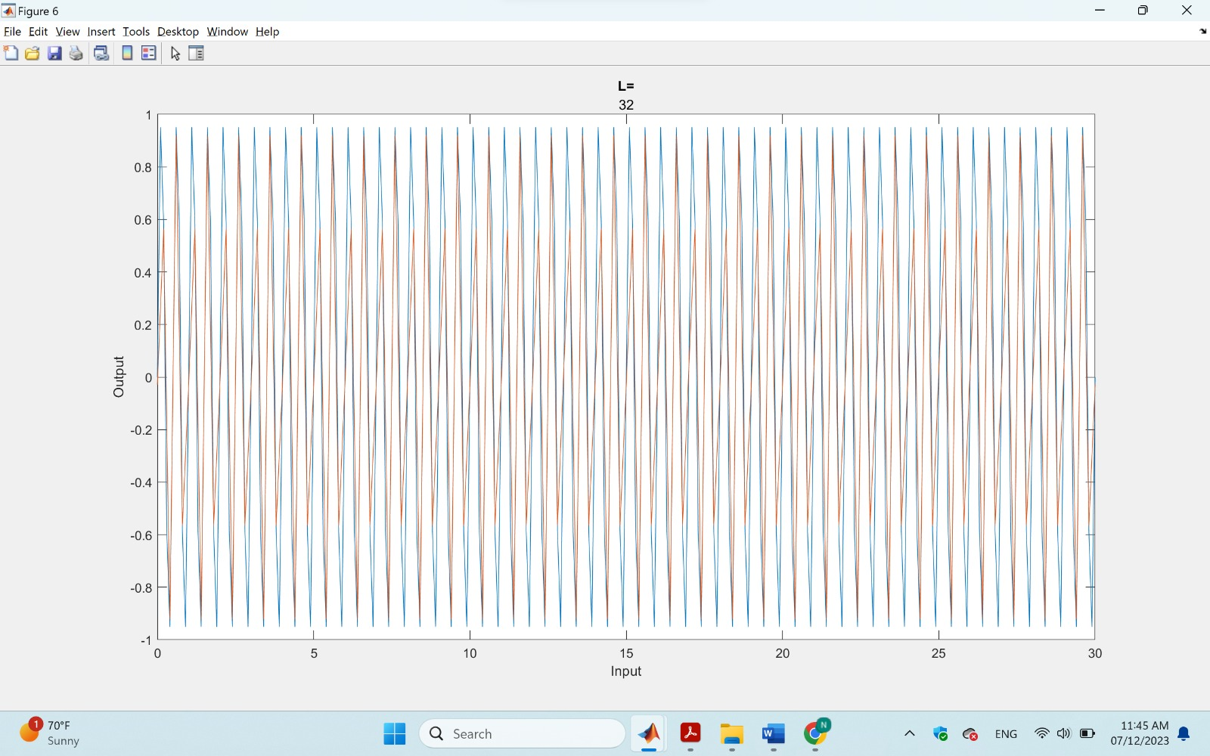
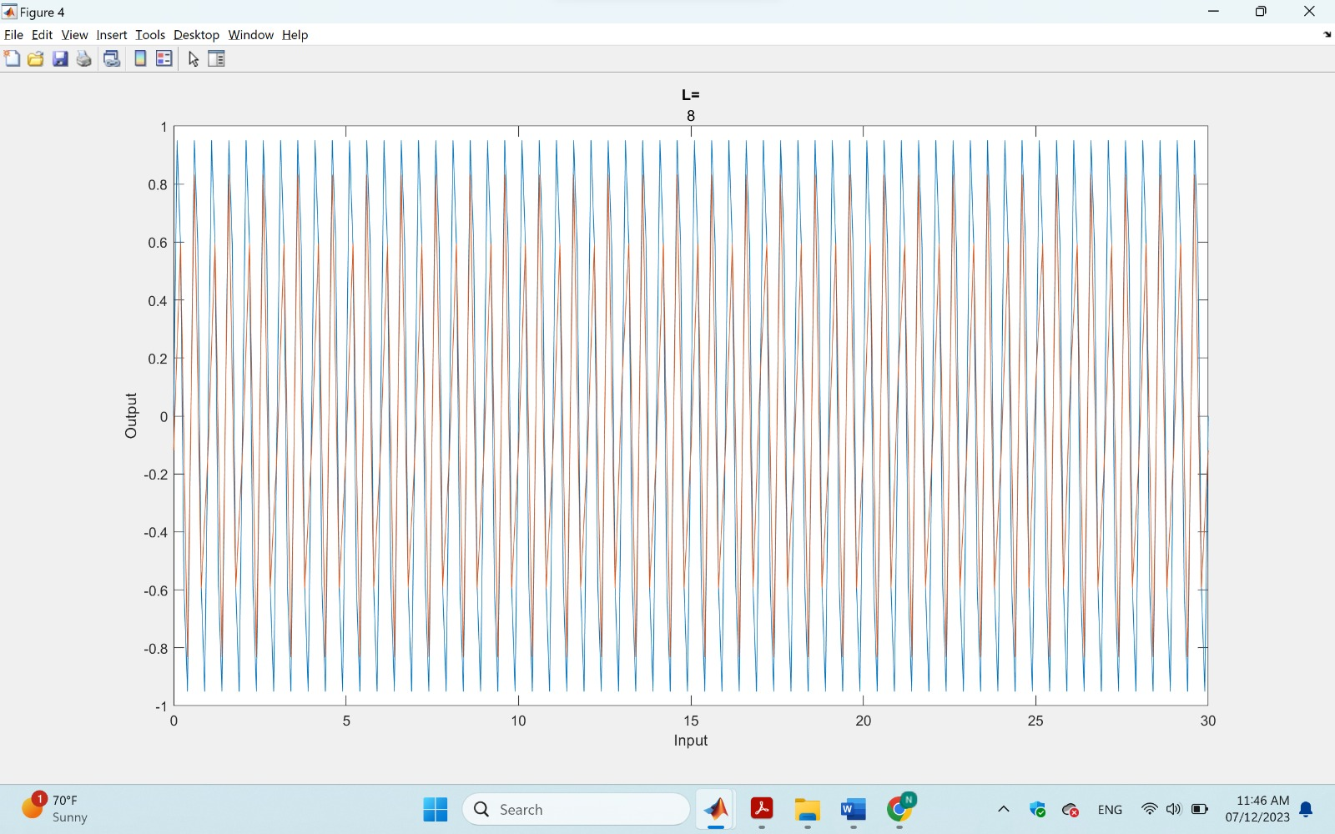
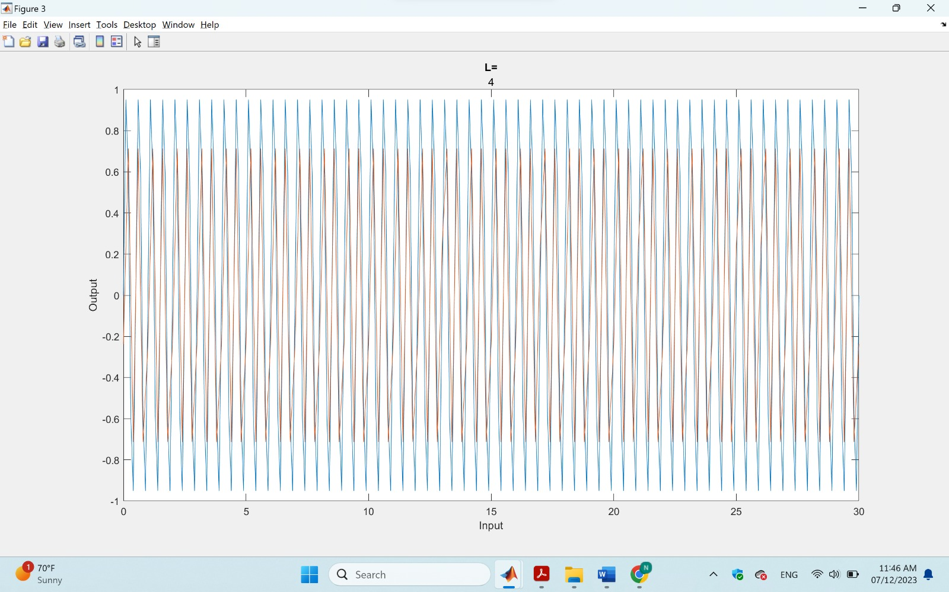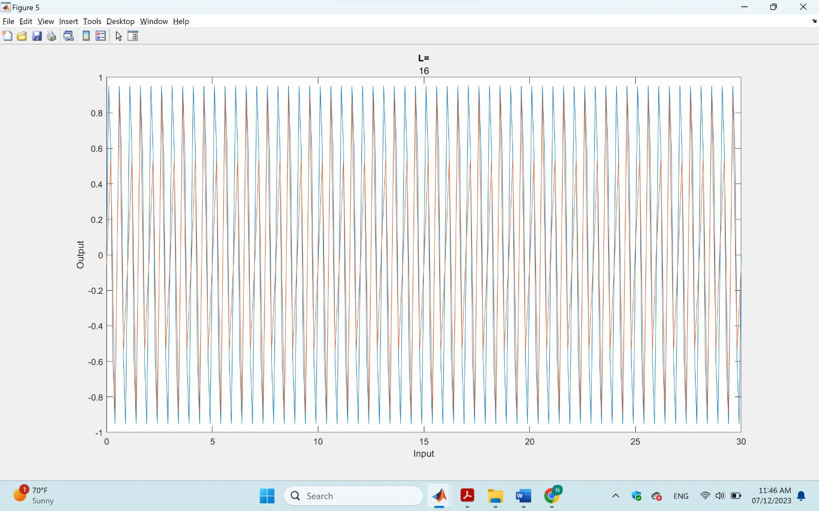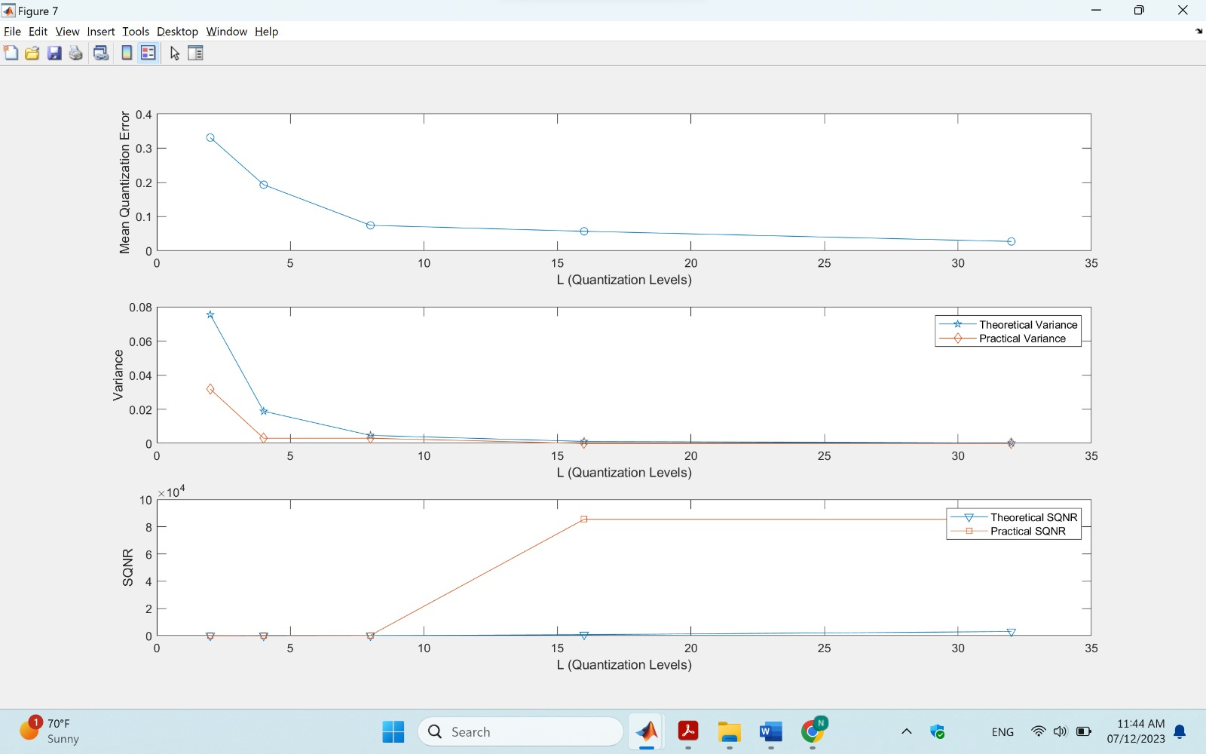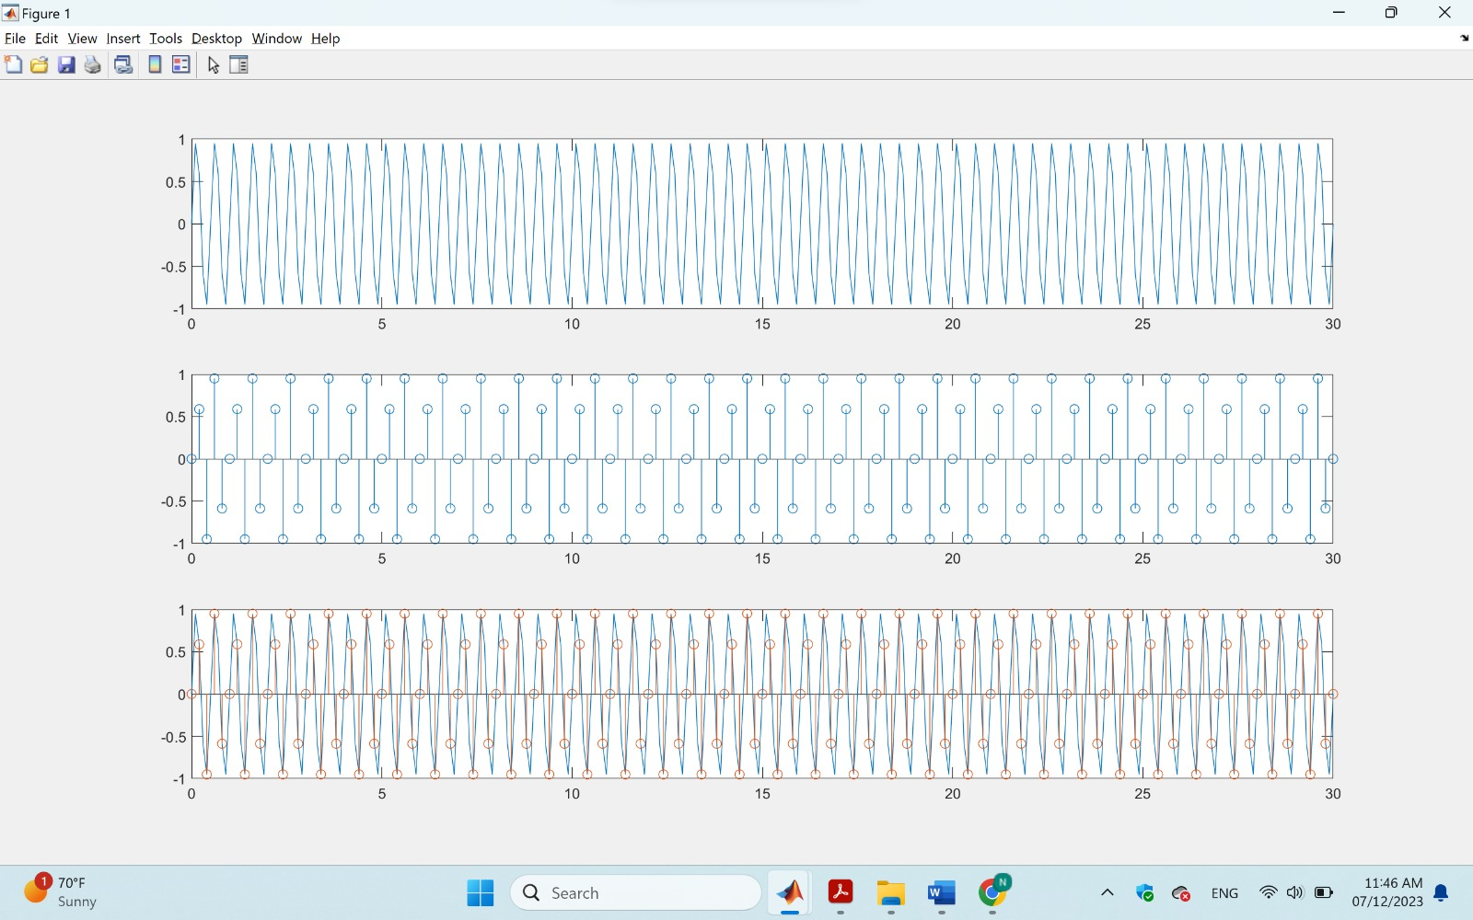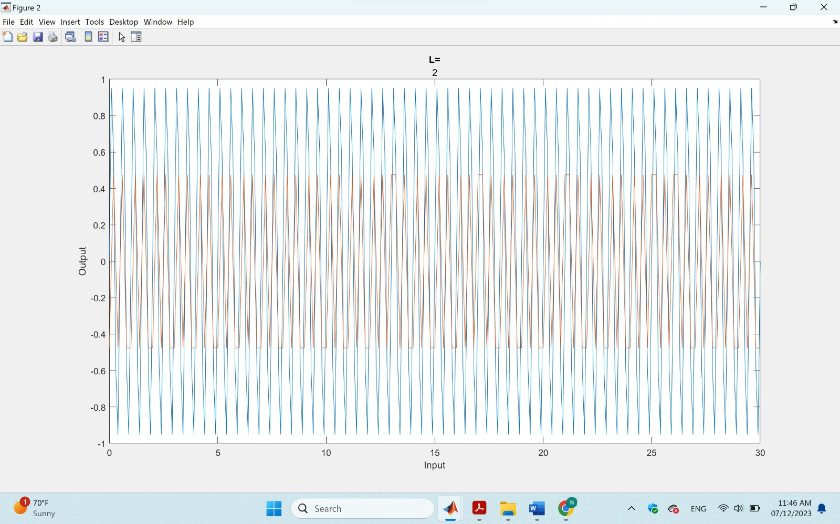
Thank you Ghadir

